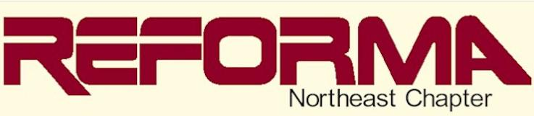
The National Association to Promote Library and Information Services to Latinos and the Spanish Speaking
Connecticut - Massachusetts - New Jersey - New York-Pennsylvania - Rhode Island

Multicultural Books and Talent Fair: Connecting Literature, Arts and People [CLAP]
CLAP mission is to:

  - Develop a plan to showcase noteworthy Spanish language materials to stimulate interest among library professionals serving Latinos and the Spanish speaking, and to promote Spanish and other World Languages libraries' collections.
  - Connect with diverse cultures and spread multicultural/diversity awareness by offering people the opportunity to showcase reminisces of their culture, traditional costumes, arts and crafts from their native countries, including but not limited to music, painting, sculptures, etc.
  - Provide Book Buzz in Spanish and other World Languages to give librarians/library workers the opportunity to learn about new trends in the publishing industry and recent reviews of notable works.

