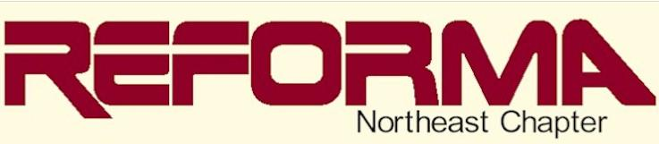
The National Association to Promote Library and Information Services to Latinos and the Spanish Speaking
Connecticut - Massachusetts - New Jersey - New York-Pennsylvania - Rhode Island

Mentoring and Coaching [MAC]
MAC mission is to:
Provide paraprofessionals, library students, and new & current librarians the opportunity to effectively deal with a diverse workplace and Spanish speaking community by helping them:
- Deepen cultural knowledge
- Provide professional guidance and support
- Offer guidance/orientation/advice/referral to address a current issue/concern
- Facilitate networking
- Encourage costumer service
- Enhance career development
- Promote professional outlook
- Demystify myths/clarify misconceptions/assumptions (e.g. staff need to know/speak the language)
- Improve performance

